**FINAL MODELS**

**1)** Parameters used during the construction of Final Model with SCS Loss method (RUN 5):

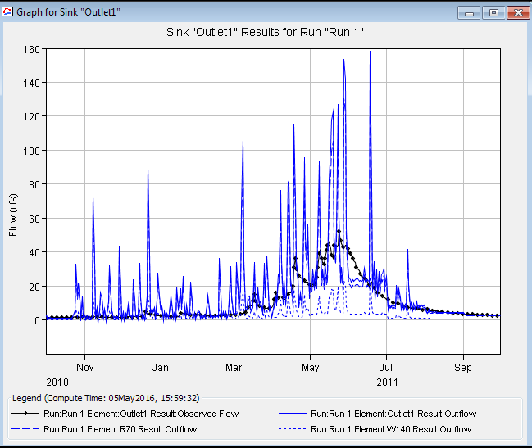

*Figure H15. The simulated and observed flow at the outlet using precipitaiton from the Salt Lake Traid for time period of Oct01-2010, Sept31-2011*

**Model Summary:**Loss Method*:* ***SCS***Transform*:* ***Mushkingum***Time Step*:* ***1-Day***Error (in %) in runoff/rainfall: **-0.2%**

**Table H1:** Sub-basin Parameter value used in this model (SCS loss method)

|  |  |  |  |  |
| --- | --- | --- | --- | --- |
| **Subbasins** | **CN** | **Impervious %** | **Intial Abstraction (in)** | **Lag time (min)** |
| W80 | 65.57 | 1.0 | 0.2 | 21.6 |
| W90 | 69.64 | 0.0 | 0.2 | 18.42 |
| W100 | 69.94 | 1.0 | 0.2 | 18.03 |
| W110 | 68.33 | 1.0 | 0.2 | 20.09 |
| W120 | 69.73 | 1.0 | 0.2 | 18.49 |
| W130 | 74.62 | 0.0 | 0.2 | 15.64 |
| W140 | 78.52 | 0.0 | 0.2 | 13.89 |

**Table H2:** Value for reach parameter used in the model

|  |  |
| --- | --- |
| Muskingum coefficient K (hour) | Muskingum coefficient x |
| 0.6 | 0.2 |

**Table H3:** Monthly Baseflow separated by WHAT for the outlet for the time period of 2010 Oct- 2011 Sept

|  |  |  |  |  |  |  |  |  |
| --- | --- | --- | --- | --- | --- | --- | --- | --- |
| Month | Total baseflow at outlet (cfs) | **W80** | **W90** | **W100** | **W110** | **W120** | **W130** | **W140** |
| 12.2% | 7.1% | 3.0% | 22.7% | 10.7% | 29.9% | 14.4% |
| Oct | 1.14 | 0.139 | 0.081 | 0.034 | 0.259 | 0.122 | 0.341 | 0.164 |
| Nov | 1.35 | 0.165 | 0.096 | 0.041 | 0.306 | 0.145 | 0.403 | 0.195 |
| Dec | 1.66 | 0.202 | 0.118 | 0.05 | 0.377 | 0.178 | 0.496 | 0.239 |
| Jan | 1.99 | 0.242 | 0.142 | 0.06 | 0.451 | 0.214 | 0.594 | 0.287 |
| Feb | 2.1 | 0.256 | 0.149 | 0.063 | 0.476 | 0.226 | 0.627 | 0.303 |
| Mar | 4.22 | 0.514 | 0.3 | 0.127 | 0.957 | 0.453 | 1.261 | 0.609 |
| Apr | 11.6 | 1.414 | 0.825 | 0.348 | 2.631 | 1.246 | 3.465 | 1.673 |
| May | 24.92 | 3.037 | 1.773 | 0.748 | 5.653 | 2.677 | 7.445 | 3.594 |
| Jun | 23 | 2.803 | 1.636 | 0.691 | 5.217 | 2.471 | 6.871 | 3.317 |
| Jul | 8.15 | 0.993 | 0.58 | 0.245 | 1.849 | 0.876 | 2.435 | 1.176 |
| Aug | 4.51 | 0.55 | 0.321 | 0.135 | 1.023 | 0.485 | 1.347 | 0.651 |
| Sep | 2.77 | 0.338 | 0.197 | 0.083 | 0.628 | 0.298 | 0.827 | 0.4 |

**2) Parameters used during the construction of Final Model with Green & Ampt Loss method:**

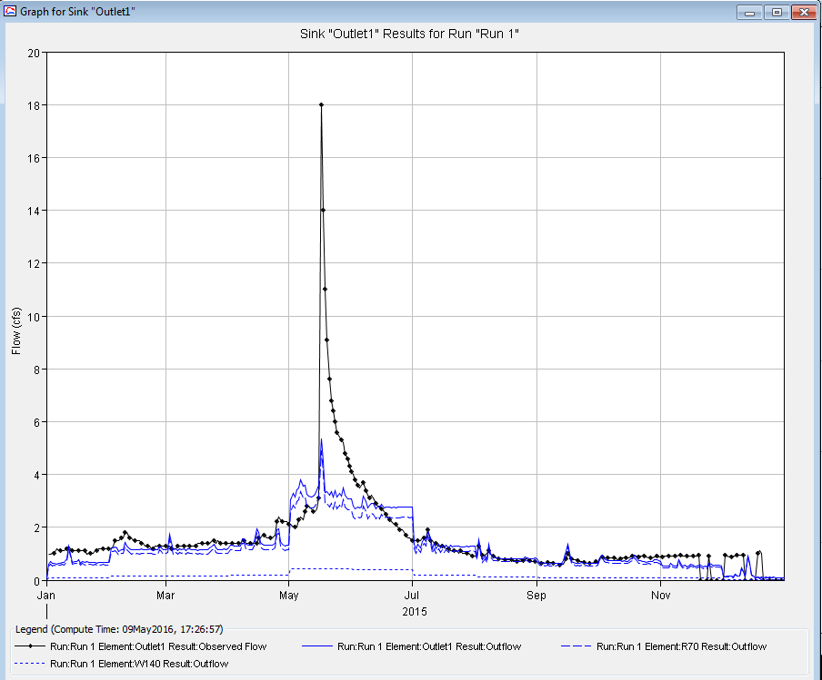

*Figure H16. The simulated and observed flow at the outlet using precipitaiton from the Knowlton Fork Climate (RB_KF_C, iUtah) for time period of Jan01-2015, Dec31-2015*

**Model Summary:**Loss Method*:* ***Green & Ampt***Transform*:* ***Mushkingum***Time Step*:* ***1-Day***Error (in %) in runoff/rainfall: **-17%**

**Table H4:** Sub-basin Parameter value used in this model (Green and Ampt loss method)

|  |  |  |  |  |  |  |  |
| --- | --- | --- | --- | --- | --- | --- | --- |
| Sub-basin | Area (sq. miles) | Suction (inch) | Saturation | Initial Moisture Content | Conductivity (in/hour) | Impervious (%) | Lag time (MIN) |
|
| W80 | 0.87644 | 7.19 | 0.388 | 0.267 | 0.332 | 1.0 | 21.6 |
| W90 | 0.51169 | 6.29 | 0.399 | 0.28 | 0.373 | 0.0 | 18.42 |
| W100 | 0.21597 | 7.46 | 0.395 | 0.28 | 0.323 | 1.0 | 18.03 |
| W110 | 1.6314 | 7.72 | 0.394 | 0.28 | 0.299 | 1.0 | 20.09 |
| W120 | 0.7727 | 7.42 | 0.371 | 0.26 | 0.429 | 1.0 | 18.49 |
| W130 | 2.1486 | 7.36 | 0.359 | 0.25 | 0.514 | 0.0 | 15.64 |
| W140 | 1.0374 | 9.3 | 0.369 | 0.26 | 0.386 | 0.0 | 13.89 |

**Table H5:** Value for reach parameter used in the model

|  |  |
| --- | --- |
| Muskingum coefficient K (hour) | Muskingum coefficient x |
| 0.6 | 0.2 |

**Table H6:** Monthly Baseflow separated by WHAT for the outlet for the time period of Jan 2015- Dec 2015

|  |  |  |  |  |  |  |  |  |
| --- | --- | --- | --- | --- | --- | --- | --- | --- |
| Month | Total baseflow at outlet (cfs) | **W80** | **W90** | **W100** | **W110** | **W120** | **W130** | **W140** |
| 12.2% | 7.1% | 3.0% | 22.7% | 10.7% | 29.9% | 14.4% |
| Jan | 0.585 | 0.071 | 0.042 | 0.018 | 0.133 | 0.063 | 0.175 | 0.084 |
| Feb | 1.061 | 0.129 | 0.075 | 0.032 | 0.241 | 0.114 | 0.317 | 0.153 |
| Mar | 1.065 | 0.13 | 0.076 | 0.032 | 0.242 | 0.114 | 0.318 | 0.154 |
| Apr | 1.198 | 0.146 | 0.085 | 0.036 | 0.272 | 0.129 | 0.358 | 0.173 |
| May | 3.031 | 0.369 | 0.216 | 0.091 | 0.688 | 0.326 | 0.905 | 0.437 |
| Jun | 2.709 | 0.33 | 0.193 | 0.081 | 0.614 | 0.291 | 0.809 | 0.391 |
| Jul | 1.206 | 0.147 | 0.086 | 0.036 | 0.274 | 0.13 | 0.36 | 0.174 |
| Aug | 0.585 | 0.093 | 0.054 | 0.023 | 0.173 | 0.082 | 0.227 | 0.11 |
| Sep | 0.576 | 0.07 | 0.041 | 0.017 | 0.131 | 0.062 | 0.172 | 0.083 |
| Oct | 0.943 | 0.078 | 0.046 | 0.019 | 0.146 | 0.069 | 0.192 | 0.093 |
| Nov | 0.477 | 0.058 | 0.034 | 0.014 | 0.108 | 0.051 | 0.142 | 0.069 |
| Dec | 0.106 | 0.013 | 0.008 | 0.003 | 0.024 | 0.011 | 0.032 | 0.015 |